Bad GS:TLA No S&Q Notes
Get dungeon layouts from http://www.goldensun-syndicate.net/tlawalk/

File Setup: Take your favourite seed which gets you:
- good stats
- granite, ground, flash, spritz, zephyr, kite
- bonus djinn: breeze, tonic
- 5Me/5J essential

Sample clear for good djinn: IFFIIIIFFF
Recall that F = clear Felixs name, I = isaac clear, i.e.
- confirm felix's name
- decline djinn transfer
- cancel isaacs name
- accept djinn transfer
- cancel
Pick your favorite name for Felix; this guide will use y~~~~
If you want to rename other people,
- x3 select to rename Felix’s party [renaming Jenna/Sheba saves frames]
- UDUD LRLR URDLU select to rename Isaac’s party [renaming Isaac saves frames]
You need to keep track of ‘bad’ enemies in slot 2 up to Shrine 2. They will influence the oob landscape. Bad enemies are Mini-Goblin, Emu, Ghoul, Harpy, Mummy, Ape, Assassin, Doom Sayer, Red Demon.
INTRO

Don’t forget to change the text speed to fast.
Just Fume everything (attack strats unlikely to save time)

Stats check: J: 64hp 44pp, F:78hp 27pp, S: 50hp, 58pp

IDEJIMA

Don't check Felix for injuries.
Talk to Jenna and Sheba, don't talk to Kraden (saves a few seconds)
Leave through the top left after Kraden talks to you btw!

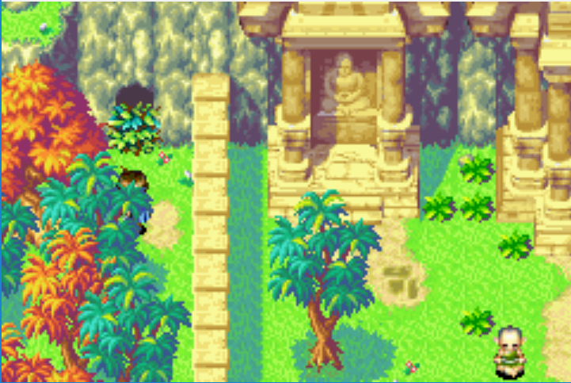
DAILA

Don't forget to say no to Echo!
Run from fights prior to Kandorean.

KANDOREAN TEMPLE

Small cutscene skip if you use Whirlwind from this position
During this menu, hotkey retreat and move, move Felix to Slot 2
Use EQ to clear fights to drain PP with Felix
Path through Kandorean is the same as Any%, retreat warps as indicated

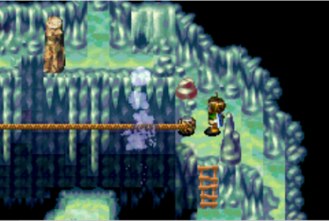
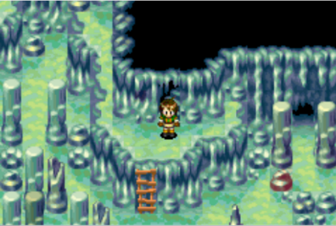

Get Lash pebble, then go through Kandorean again to get to Fog
Fog:
Fume/Def/Ray
Fume/Def/Def

Retreat through both of these doors to escape Kandorean (you can leave through the gate)
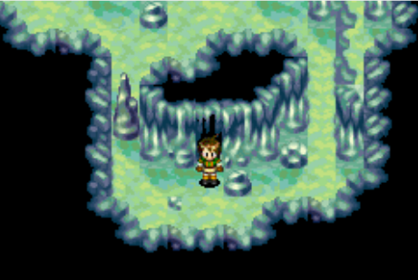
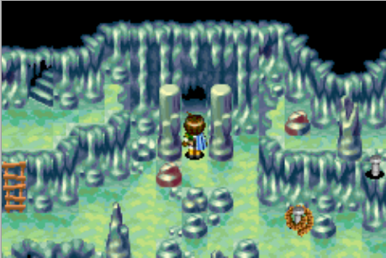

Off to Shrine of the Sea God

SHRINE OF THE SEA GOD

Go get Breath; same strats as any%
Retreat through the following doors then do the oob instructions here ->
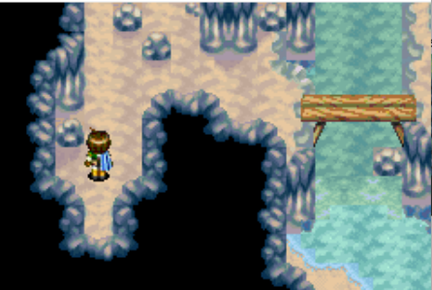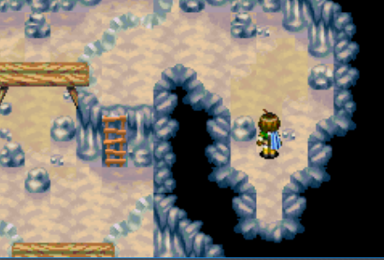
+3s Up then left, or hold left upon reacting to screen flash. Red line is aligned with the door at the bottom of the screen.

Breath:
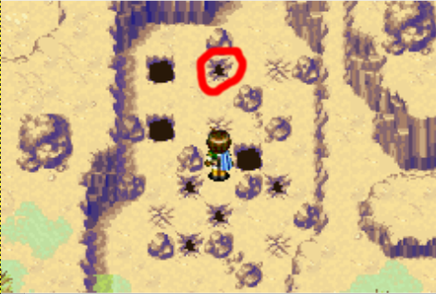
Fume/[Atk-Echo]/Ray
Fume/Venus/Def
Retreat out of Shrine afterwards.

DEHKAN PLATEAU

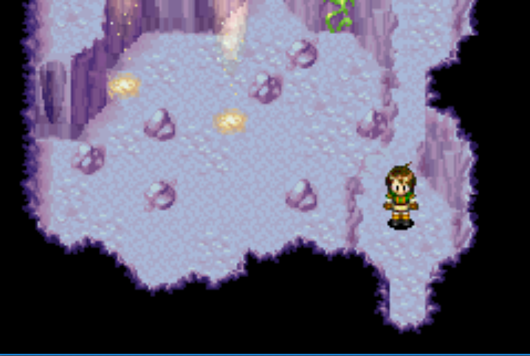
Kill stuff with Ray, Fume, Atk[F]. Set Breath at a convenient time [e.g. Metal Vest menu]
Path is same as any% except get Themis Axe. Fall down to get the Mint (the red crack below).
Retreat mode, access the mint chest and get the Full Metal Vest (equip to Jenna)
Retreat warp out of the door in this room.

If you’re all beat up, go to Madra and heal, getting Iron outside Madra.
More likely, get Iron from the Forest immediately above the Madra retreat warp point then go get Cannon. Equip things after the warp or in a menu to check PP prior to warping, set breath!

Iron:
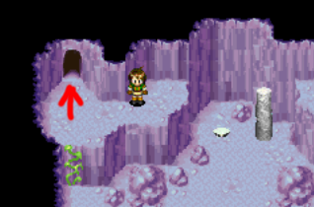
Fume/Atk/Ray,
Fume/Def/Ray

Cannon: [pick all left or all right action based on your PP]
[Fume-Atk]/Echo/Ray
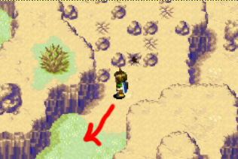
[Atk-Ramses]/[Ramses-Def]/[Def-Ray]

Retreat after Cannon and go to Madra

MADRA
Low pp backup warp
Djinn: J: Iron/Fog, F: Echo/Cannon, S: Breath

Take the Inn, get the Nurse Cap.
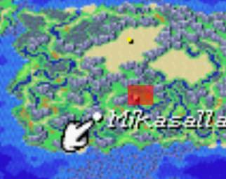
Next stop Mikasalla
Get the Pirate Sword [and Guardian Ring if playing safe]
In Lash menu prior to Psword configure djinn:
J: Cannon/Fog(sb), F: V, S: J
Keep killing things with Ray, Fume or Ray+Fume

MIKASALLA
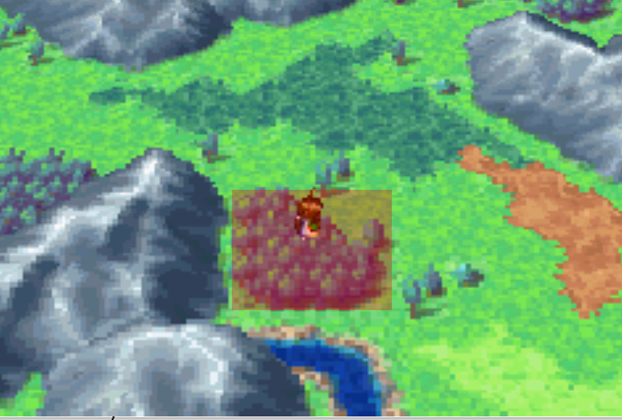
Take the Inn. Get Lucky Pepper next to Fireplace in Inn
Sell: Pirate Sword
Buy: Broad Axe [F], Bronze Helm [F], Herbs [S], x3 Sacred Feather [S]
S to slot 1, J to slot 3 [and any psynergy items to Sheba for use against upcoming mobs]
Items: Nurse [+ G-Ring] to Sheba

Sour is scary, but doable. Sour’s location is indicated on the right. (It’s just below where Megaera is)
Sour:
 | S: Ray | F: Atk, Spire | J: Fume, F. Wall
Momonga | X~ | X [X] | [X]
Kobold | X | X [X] | X
Dino | X | Atk [X] | X
Troll |  | X | X*
Emu | X* | [X] | X* [Fume]
Ghoul |  | X | X
Harpy | X | X [X] | [X]
Creeper | X | X [X] | [X]
Mummy |  | X | X*
Ray/Spire/Fume,
[Ray if lv6]/Echo/Fume
Should be 7/7/7. Now we’re off to Airs Rock.

PP Requirements:
Sheba needs 35 pp for Airs Rock,
Felix needs 12 pp for retreats.
Kill Table:
[] indicates second set of attacks that kill,
* means targeted, ~ indicates a range

Felix needs to have PP run out for the Blind Climb, so heal and spire strategically.

AIRS ROCK [Emu, Ghoul, Mummy, Harpy in slot 2 cause ‘bad’ oob]

Room 1: Follow the red path, then follow the blue path. Retreat after this statue.
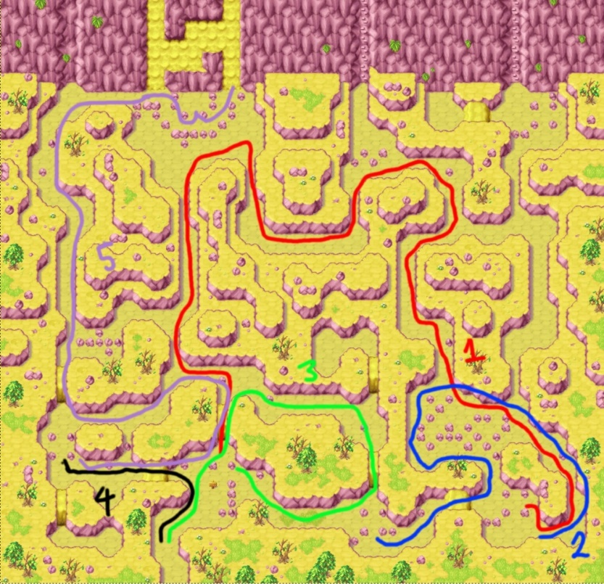
Then follow the green path, retreat after this statue.
Then follow the black path, then purple path

R2: Once you climb up there is a choice between an obvious
climbing face and a less obvious one to the left,
take the one on the left. Everything else is standard.

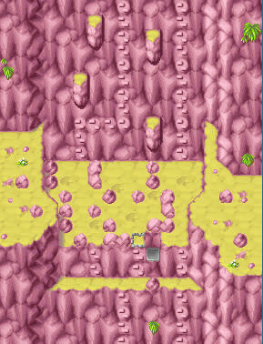
If doing the blind climb, mash select and navigate this area:

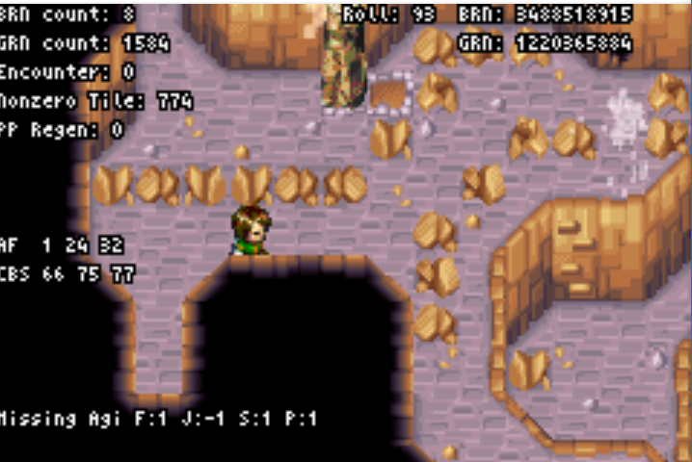
INTERIOR

Avoid the Psy Crystal if you can, use Ramses if you’re really stuck.
Work through the red path first in the usual way.
[Keep in mind this rom is high pp regen so use PP with Felix].

In the second red room there is a wind current thing that stops
you from progressing - retreat mode turns it off.
Can get encounters against the horizontal wall depicted to the
Right to exit retreat mode. (yes you need to run against the wall)
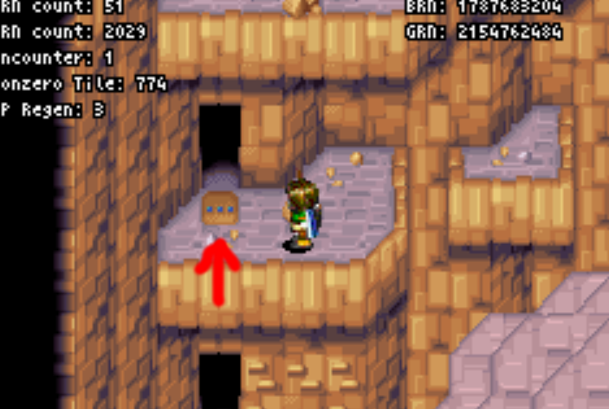
Retreat warp through the Blue 3 dot door in the main chamber
after this. (Will drop you down into the main chamber)
Activate WW statue, hit the Bowie door, then ride the WW.

Go get Sol Blade (DO NOT RETREAT MODE BEFORE PUSHING PILLARS)
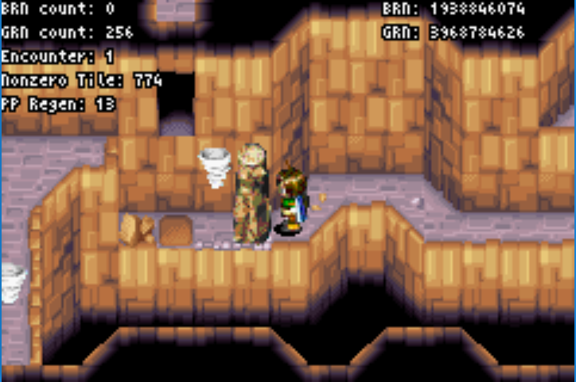
With retreat mode, walk ‘out’ of Airs Rock to warp to the 1-Yellow door. If PP is low can retreat through the 1-Yellow door to get to the 2-Blue door to save frames.
Retain current Djinn setup

2-Blue door has a new skip:
In retreat mode, push the log one space left [picture to the right]
Then navigate to the position below:
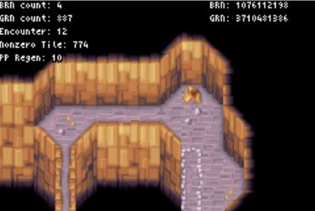
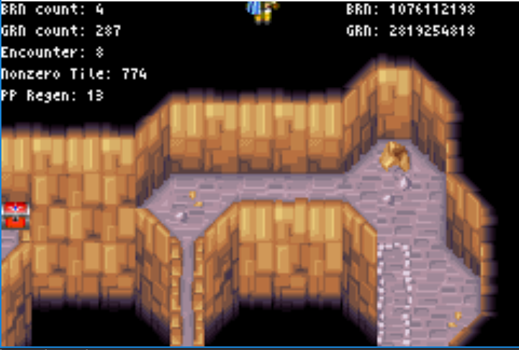
Hold Up [saves at least 20s]
If Ghoul OOB then Up to Wobble, Right until-> then Up+Left to get the chest alignment back, then hold up.
Get the Vial from the 5-blue room puzzle (the long hallway room).

Expecting 9/9/9 leaving Airs Rock. Use Avoid in the overworld afterwards if at 10/10/10.
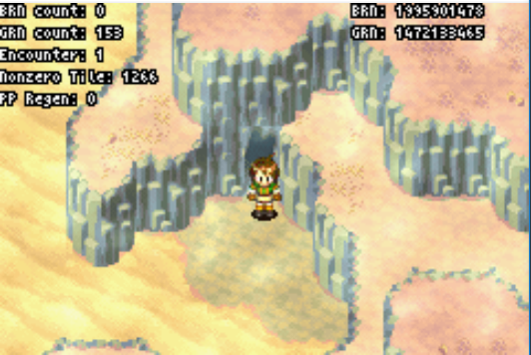

YAMPI DESERT [Avoid: lvl9]

Reserve Yampi can be tricky. Firstly get oob by retreat warping through this door.

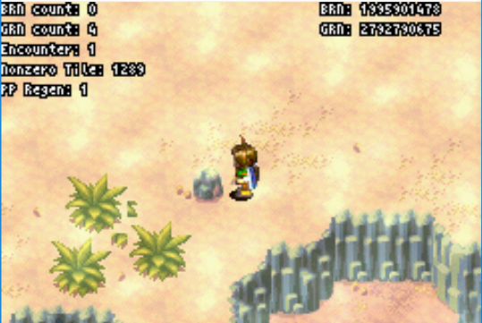
Then align to the right of this rock and run up. When the screen moves hold Up+Right.

If you have Min-Goblin OOB then in the top left (0,0) go left for about 2-3 units then hold up+left
[will send you to door 3 without goblin oob!]

shit hits the fan strat: [Up+Right reveals unfinished edge of map]
UR until stop moving, UL until stop moving, UR until stop moving
UL until stop moving, R until stop moving, D one unit, R until out

ALHAFRA

Djinn: Breath [s] <-> Fog [j] <-> Iron [f]
Sheba: 2Me, Felix: Echo/Breath, Jenna: Iron/Cannon, [breath to outspeed SeaF]

Briggs: Felix: Echo one of the sea fighters, then atk Briggs until dead.
Sheba: x2 Impact on Felix, then plasma or heal
Jenna: Iron then Ramses, then FlareWall, Iron or Herb.

Sample fight [no megiddo, all signal whistle]
Briggs:
T1: Impact (F)/Echo (SeaF)/Iron
T2: Impact (F)/Atk(Briggs)/Ramses
T3: Plasma/Atk(Briggs)/Flare Wall
T4: Plasma/Echo(Briggs)-Atk/Iron
T5: Plasma/Atk(Briggs)-Echo/Ramses-Flare Wall

This fight sucks. Paradoxically, your best odds come from not healing as the longer the fight goes on the move likely it is SeaFs start using Oil Drops [they will use them after smoke bomb -> herb].
Briggs dies with Megiddo + Echo or x3 Atk + Echo.
Once Briggs is dead Atk from F will kill SeaF with any incidental damage (but not from full HP).
Defend tends to make the AI avoid the target so only use it when you really need to.
Healing can be used, Sheba outspeeds SeaF but not Briggs. Jenna doesn’t outspeed.
Alternate setup; F: Cannon/Breath, J: 2V can give J more survivability but you need to FW target SeaF to kill on T1.
Alternate strat; F kills SeaFs instead of Briggs. Fight is slow but probably better odds. Warning that Briggs will use Herb, Oildrop, Nut after running out of Signal Whistles.

Get Lucky medal now. Psy crystal later (we need it for Gaia Rock)

YAMPI DESERT

Djinn: S: J, Ma, F: Me, J: V. Spam Avoid! [I hotkey Avoid to L, Pound over R]
Backtrack through yampi to set the retreat pointer to the West exit (madra side) then proceed
[Pickup G-Ring if you haven’t already.]
Use avoid Prior to Blitz (to keep it until KS)
Get Blitz: S: J,Ma F:V J:Me
Def/Echo/Def

Afterwards, S: J, F: V, J: Me/Cannon

Heal prior to King Scorp to drain PP, Avoid with Jenna to stop Overworld encounters.
King Scorpion: Impact x2/Atk/Def then spam Atk with Felix (after 4th atk use Echo to kill if no defend)
After scooping out of KS room, go into retreat mode, then exit out of the south exit to Madra warp.

GONDOWAN CLIFFS

Rely on Sol Blade to kill things, psynergy generally just waste time.
Djinn: S: V, F: J, J: Me/Cannon [allows Felix to outspeed Gorillas]

KINDLE: Atk, if no Megiddo then Impact+Blitz next turn.

NARIBWE

Sell Bronze Helm, Vials, Broad Axe + anything else of value. Buy:
Jenna: Psynergy Rod (or Rapier if poor), Silver Circlet
Sheba: Adepts Clothes
Felix: Iron Shield
Items: Thorn Crown to Felix
Djinn: Echo [s] -> Felix, Cannon [j] <-> Iron [s]

S: 2Ma, F: Echo+2J, J: Iron+2Me

Fights can vary wildly in time
- 1 enemy: sol blade / astral blast
- 2 or 3 weak enemies: plasma/Mad Blast
- 2 strong enemies: atk/astral one target, plasma+CE other target
- 2 strong 1 weak: T1: CE weak, atk strong, T2: atk strong (psynergy if battle rapier on J)
- 3 strong enemies: take out 2 enemies first, then 1 enemy on the next turn
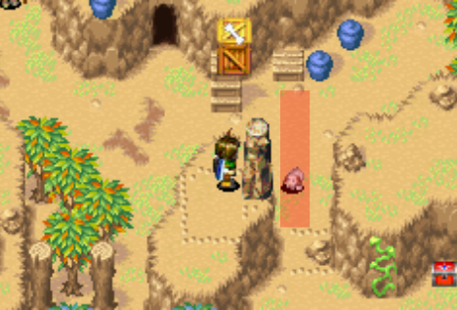
KIBOMBO MOUNTAINS

Start pushing the log when dog is in the red area (going up or down)

GABOMBA [Bad oob: Doom Sayer, Red Demon]

Prior to scoop: Sour [s] <-> Breath [f], Piers slot 3
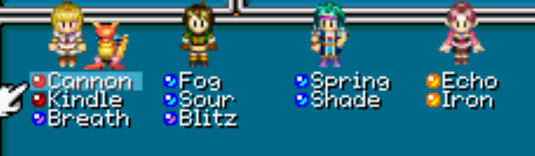
Fights are pretty complicated here
- Generally, treat fights as Felix killing one target and everyone else killing the remaining targets
- Felix CE or Atk kills anything except Red Demon, Salamander
- Felix CE + Atk from J or P kills anything. Felix Atk+Atk[j]+Atk[p] kills anything w/o Megiddo.
- Spirits, Doomsayers die to Atk[j]+Atk[p] or Plasma+atk
- Skeletons/Death Head die to PD[j]/DD[p] + Atk from the other person. Skeletons can die to Plasma+Mad Growth [range if MG isn’t targetted]
- Demon/Doom can be cleared by CE+Atk[j] on Demon, Atk[s]+DD on Doom. Otherwise Wind Slash target on demon is best bet.
- Demon/Demon fastest to split across two turns. Otherwise CE+Wind Slash targeted, PD/DD on the other.
Spam CE with Felix to prep for the retreat glitch to unload ladder loading zones so you can walk on the wall to get to the other side [after using pound on the sparkly gear]. Hotkey pound to L when pounding at sparkly gear.

Steel: Plasma/Sour/DD/PD [sour is stronger than blitz]

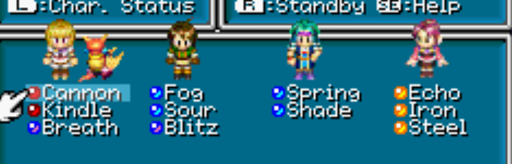
Djinn setup should be [do this during lash menu]
Sheba: Cannon Kindle Breath
Felix: Fog Sour Blitz
Piers: Spring Shade
Jenna: Echo Iron Steel
We keep this setup until Boat

KIBOMBO MOUNTAINS [14/14/18/13] [Bad oob encounters in slot 2: Assassin, Gorilla]
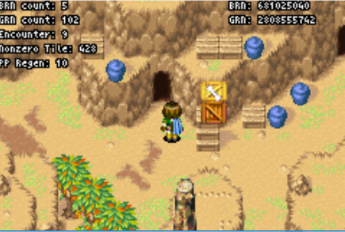
Don’t take the Inn in Kibombo, we will madra warp to get back to Gondowan Cliffs
Waft: Plasma/Sour/DD/PD
Waft should go to Piers, SB all J djinn for Procne

Keep killing things as we have done using Procne in place of psynergy to clear things fast.
Retreat warp through this cave after re-entering from the south entrance

Use Avoid prior to the retreat warp

GONDOWAN CLIFFS [avoid works at 14/14/18/14] [Bad oob: Gorilla]

Get the Healing Mushroom then retreat back to the entrance.
Avoid after the cliffs back to Madra, do the Madra cutscenes, get Char
Take the Madra Inn to recover PP.
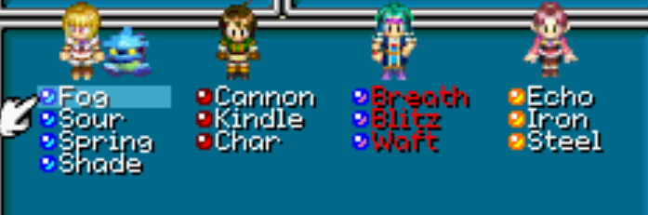
BOAT

Djinn: S: Me, F: Ma, P: J, J: V
Frost over Retreat on first Frosting
Aqua Jelly – PD with Felix to drain PP [we go to Shrine next]. Char/Cannon after PP dead.

AQUA HYDRA

Speed of strat depends on Megiddo. Can pick up oil drop, not sure if it helps.

S: Impact on F first turn, then either Wish, Impact (J) if T2 or Def
F: Atk every turn.
P: Impact on F first turn, then Breath/Blitz/Waft in some order depending on needs.
J: PDs every turn.

Sample Fight:
T1: Impact(F)/Atk/Impact(F)/PD
T2: Impact(J)-Wish/Atk/Waft/PD
T3: Wish/Atk/Blitz/PD
T4: Procne/Atk/Breath/PD
T5: Oil/Atk/Def/PD

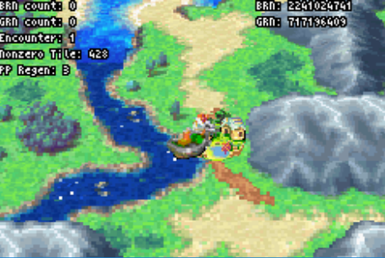
Hydra has 2776 HP

SHRINE OF THE SEA GOD [Bad oob: Gillman]

Sail to the side of Daila (hug the cliff to minimise encounters where applicable). Unload boat into top half of Daila so that you spawn near the Sanctum. If positioned right, you can board the boat without entering Daila after Shrine. Use the Sacred Feather prior to the first retreat warp in Shrine when you check Felix’s PP.
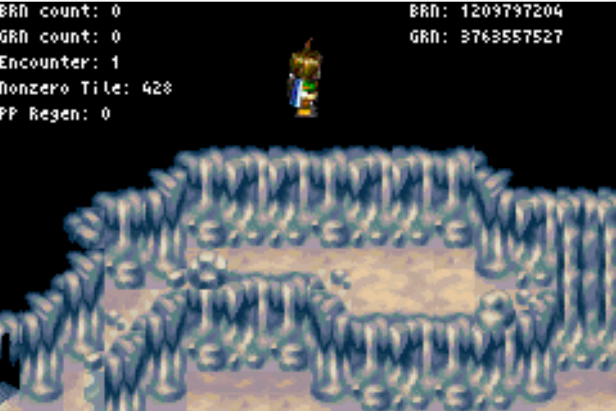
Need to do a different retreat warp in Shrine since you have
Kibombo Map data loaded.

While other OOB warps exist, generally we’re going to use the following setup. [Works for at least Red Demon, Ape, Mini-Goblin]

Hold up until the screen shifts (it should reveal all of the door). Hold right until the door leaves the screen then up to the warp. Backup warps as follows:

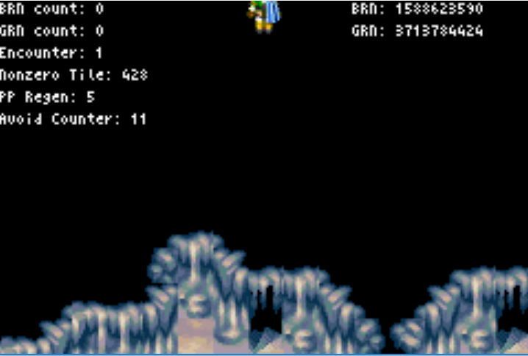
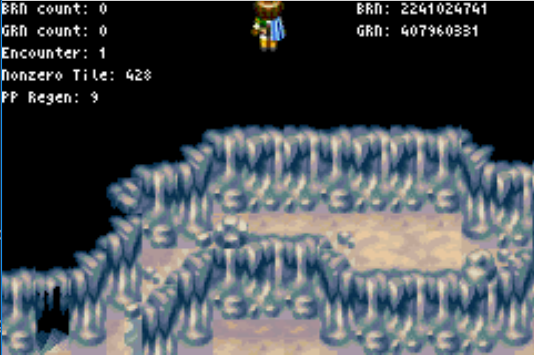
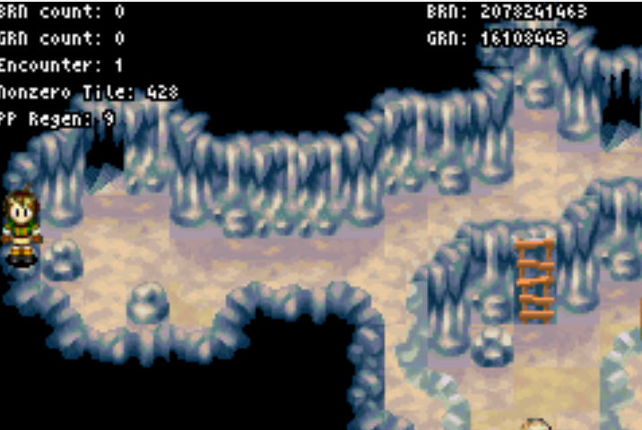
Gillman OOB:
Move up from this position until the screen shakes, then up+left until the screen stops moving. Up+right until the screen stops moving. Hold left until the screen stops moving (should be one unit), then hold down for the warp.

Assassin OOB:
Hold up for a few seconds to run into a wall. Then down+right until the door on the bottom left is cut off. Then hold up.

Doomsayer OOB:
From the given position, one unit left (i.e. Felix just leave the screen) then hold up+left until the screen flashes. Hold right for a second, then up to warp.

Cyclone Chip to Jenna in the same menu as using the Sea God’s Tear
Collect Trident piece, Retreat afterwards, then sail to Kibombo.
Go get mud.
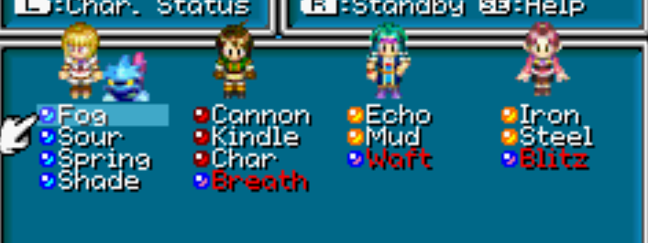
Mud: Procne/Atk/Atk/PD [don’t take the Kibombo Inn]

Djinn menu: Mud[f,set] <-> Breath [p]
Blitz[p] <-> Echo [j]
SB all J djinn.
- use Procne to clear 3 enemy mobs. Gillmen need Procne+x2 blast (not targeted) or Proc+PD.
- Use attacks to clear single targets.
- SB djinn cycle: Right -> Up [R to SB] -> Right -> Up [R to SB] -> Right [R to SB]
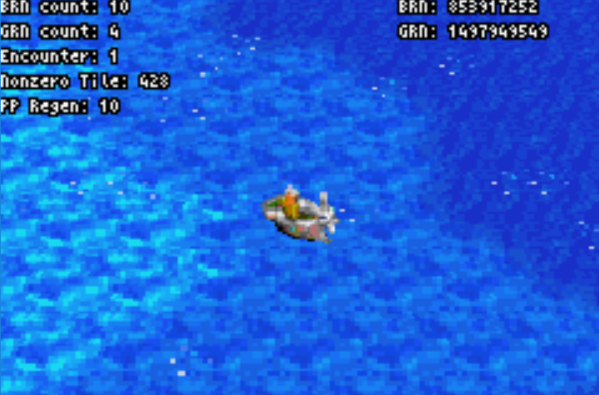
Now we sail to Apojii. Down+Left after top of Indra until image at Right, then hold right.

APOJII ISLANDS

Shopping: buy Jenna the Anhk, Great Sword to Piers [in this order]
Activate Teardrop Stone [don’t hotkey]

AQUA ROCK [15/16/19/15]

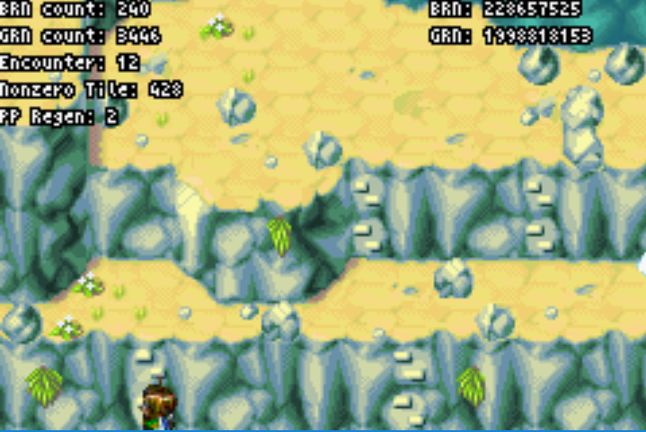
Kill Table: [ ] means also kills but only used if x2 of enemy
 | S: Procne | F: PD/Atk | P: Atk | J: Atk/PD
Faery | If mob | Atk for x1 | -- | --
Calamar | If mob | Atk for x1 | -- | --
Roc | Always | Atk | Atk if x2+ | Atk if x2+
Virago | If mob | PD for x1 | -- | PD if x2+
Lizard | Always | [Atk] | Atk | Atk
TDragon | Always | PD | [Atk if x2] | [PD if x2]

Heal with Felix entering Aqua Rock to drain as much PP as possible.
Do the 1-2s timesave retreat warp (pictured) to skip the move puzzle in the first room. (Get encounter, fall down waterfall. Can get the encounter after falling down the waterfall)
Hotkey Douse over Retreat at first instance

Otherwise, nothing too interesting going on here. There are no other retreat skips in this dungeon. Get the Psy Stone upon entering interior. Don’t get Steam.

After Parch, x2 retreat to leave and set sail for Tundaria (Down+left basically all the way)

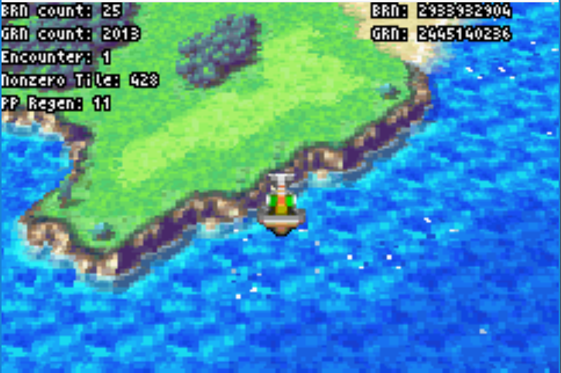
TUNDARIA

Once the boat gets to this position, go down until the depicted configuration of sea glimmers (the sea glimmers will change upon crossing into the no encounter area). Go Down+Left after this.

If you see shallow water you’ve gone too far but that’s ok. Encounters will stop in the water to Tundaria.
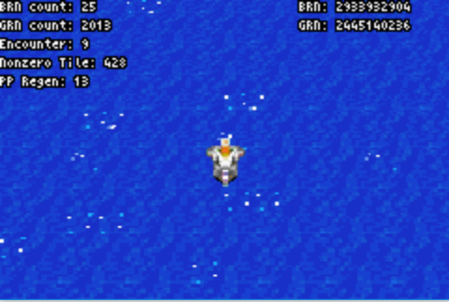
Don’t visit any intermediate town on the way to Tundaria.

This place can be brutal. Piers has revive with 4Venus at 19. Retain the Procne setup. Procne kills anything targeted, will NOT kill Dinox / Needle Egg not targeted.

Delay Wheeze until after Tundaria Tower

TUNDARIA TOWER

Kill Table, [] indicated kills only if targeted. Play smart and be flexible, this place is deadly.

 | S: Procne | F: | P: Atk | J:
Squirrel | X
Needle | [X] | -- | Atk no mob | Blast if mob
Dinox | [X] | [Atk] | -- | [Atk]
Stone S | X | Atk non-target | Atk targetted | [PD works]
Harridan | X | Atk non-target | -- | [PD] target
Minotaur | X | Atk non-target | -- | [PD] target
Living A | X | [Atk] | Atk targetted | [PD]
Magicore | X | Atk | -- | Atk
[Magicore strat kills untargeted]

No retreat warps, just be sure to pay attention to your PP management.
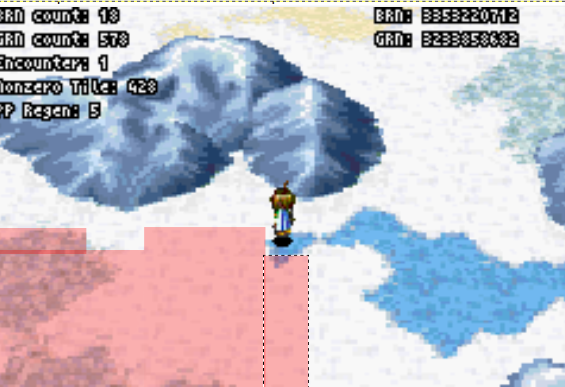
You’ll want to get Reflux, to do this in the room with three stair cases take the center stair case.

REFLUX: Shade/Judgement/Boreas/Def

Recover three djinn in Reflux room, last djinn outside this room
Leave Reflux on Piers.
After the prong go get Wheeze. Wheeze’s area is the shaded red area to the right. Yes the area is irregular.

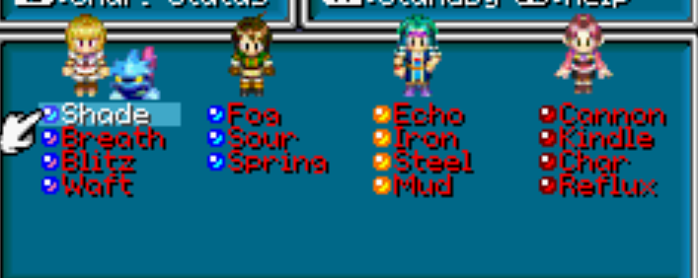
Djinn: SB all, set Shade [can save time by not using shade fwiw]
Fog [s] <-> Breath [f]
Char [f] <-> Sour [s] <-> Blitz [j]
Reflux [p] <-> Iron [j]
Waft [p] <-> Steel [j] <-> Kindle [f] <-> Spring [s]
Cannon [f] -> Jenna

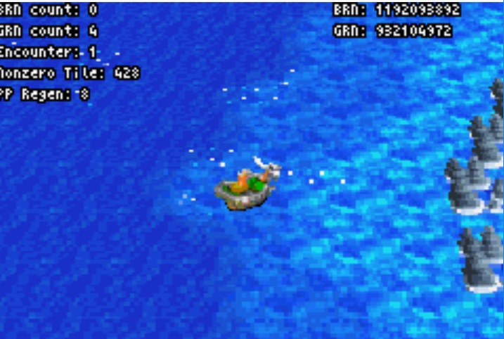
Wheeze: Shade/Atk/Boreas/Meteor

Now die to warp to Apojii Islands [Use summon fails to die fast].
Revive with Piers instead of Sanctum (or Felix if at 19). Then set up S: J, F: Me, P: V, J: Ma
Ply Well with Felix to recover HP

Use Flare Storm [Jenna: 18] + Tornado. F Atk to clear single target.
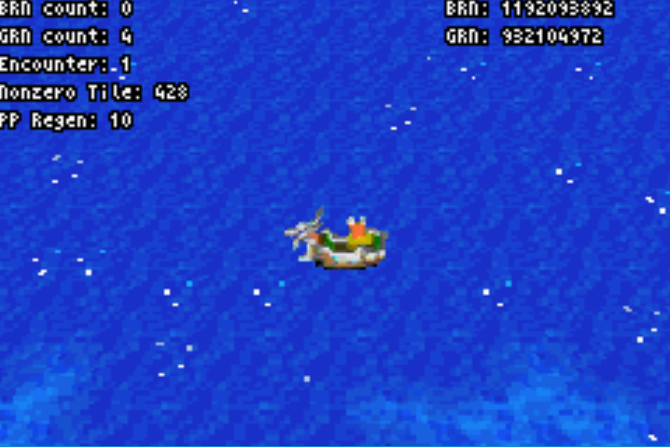
Gillmen not targeted will survive with ~8hp so anything else will kill

Down+Left leaving Apoji until the rocks in the first image are cut off.
Then go Left until the second shallow patch is on screen as in the second image.
Use Avoid when walking to Alhafra.

ALHAFRA

Get the Alhafra Lucky Medal [if didn’t get it earlier]
Solve all of the ship puzzle now. Cutscenes are fun. Get Psy Crystal after Mayors house.
Afterwards off to Gaia Rock. Go Up+Right until you are through the sea of time fog, then go up.

GAIA ROCK

Visit Izumo before Gaia Rock, pick up the third Psy Crystal, War Gloves, and Water of Life [to Felix]

Setup: J:Ma F:Me P:V S:J [about 10 fights of FlareS/Tornado]
Use F atk to clear single target worm, gnome, wight, vermin.
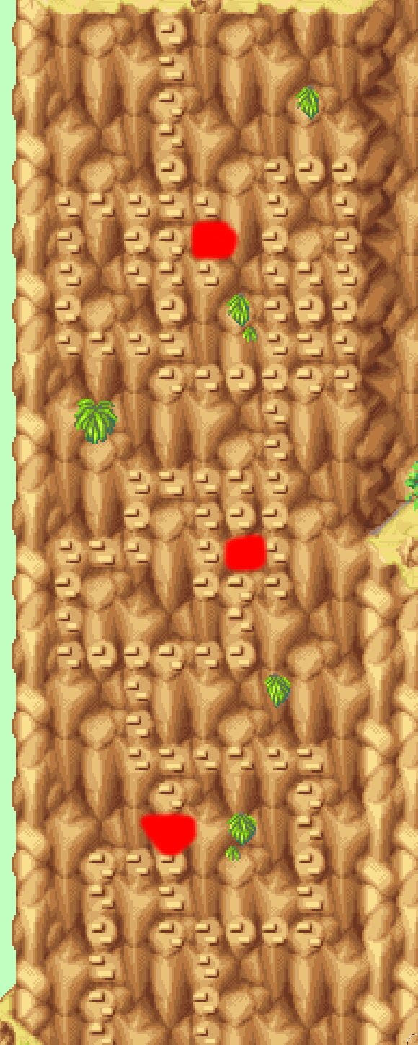
Psy Crystals are for Jenna/Sheba once they run out of PP

[Note that Fire Worms give the most EXP at 153. Average encounter EXP is somewhere in the 200 range]

 | FlareS [J] | Tornado [S] | Atk [P] | Atk [F]
Fire Worm | X [if mob] | X | - | -
Gnome | X | X | If both FS/T no target | -
Wight | X | X | If both FS/T no target | -
Gargoyle | X [target] | X [target] | X | -
Golem | X | X | - | X
WoodW | X | X | X | -
Vermin | X | X | - | -
Hound | X | X | - | X

Go into the interior and progress to the maze. SB all djinn on Felix when solving the move puzzle, keep them this way for Gaia. Retreat warp back out of the maze
to skip the first exterior screen [~40s time save]. Go left after the warp.

Use the map on the right to not hit Moai when climbing the wall.

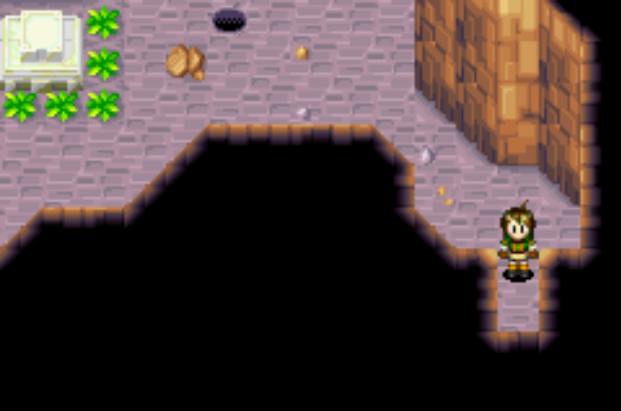
Get the Dancing Idol. Retreat back to the entrance.
Take the Right Path first in the interior. Follow the path through to the cyclone-able grass. Cycloning any patch will trigger the platforms to spawn (i.e. cyclone from max distance possible)
Then take the left path. When you come to the ‘main’ light room, activate the cyclone and idol table lights. Then continue to the climbing wall, don’t go on the climbing wall – progress below the climbing wall to the third idol table. Activate this. Now get into retreat mode and leave this room. This will warp you to the Maze.

Path through the maze: UU[L]LDDDR[D]RDRRU
[] indicates a room with a chest in it (to help you navigate better)

SERPENT [20/20/22/20] [fight is possible w/ Wish on Piers, but at least 40% chance to die]
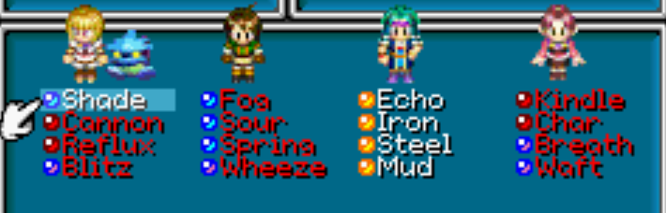
Wheeze [s] <-> Shade [f]
Reflux [j] <-> Waft [s]
Breath [s] <-> Cannon [j]
SB all, Double Tap Breath
Set V djinn on Piers, Shade [s]

T1: Thor/Atk/WishWell/Meteor
T2: Shade/Atk/WW/Boreas
T3: Blitz/Wheeze/WW/Waft
T4: Thor/Atk/WW/Breath[s]

Get Sand, skip Cloud Brand.
If not enough PP for retreat, just backtrack to the move puzzle and recover 6pp there.
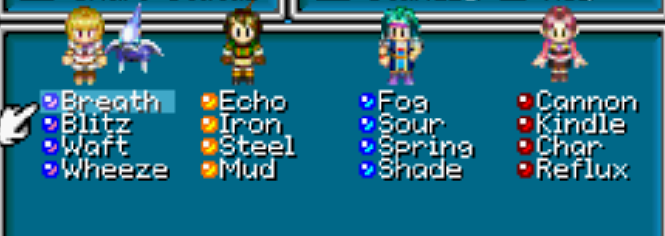
Izumo: Take the Inn [Festival Coat to S here for Poseidon safety]
Fix djinn:
Shade [s] <-> Wheeze [f] <-> Echo [p]
Spring [f] <-> Iron [p]
Fog [f] <-> Steel [p]
Mud [p] <-> Sour [f]
Reflux [s] <-> Cannon [j]
Waft [j] <-> Reflux [s]

ANKHOL RUINS

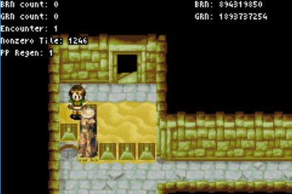
Kill Table: (*one target, **two target)
 | Tornado [s] | F. Storm [J] | Atk [p] | Atk [f]
Dinox | X* | X*
Squirrel | X | X
Minotaur | X | X |  | X
Armor | X** | X**
WoodW | X | X | X
Harridan | X | X |  | X

Progress through the left side until activating the sand flow, then retreat. Then go back through the left side (through the WW door this time) and follow this through until pushing the first half of the face in the main room back together.
Go up through the door, then the door on the north side in this next room.
Use Sand to wedge Felix into the position as indicated to get Move to connect. Progress through the door below the pillar.
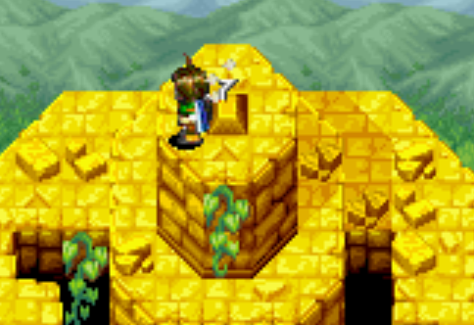
Push the second half of the face in to the main room to activate the sand flow, then backtrack to the left side to complete the dungeon.

To get the Prong, from the given position, move Right below the prong, then hold left briefly to cause felix to look up, then when felix is looking up or looking up+right press A

Hotkey Retreat over Sand after the prong. Use Avoid before you leave.
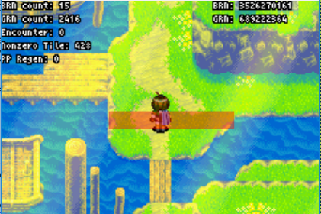
Head to Champa, trigger the Alex cutscene early via running to the red line then attempting to leave Champa.
AVIMANDER [20/21/22/21]

Echo [f] <-> Reflux [j] <-> Fog [p]
Shade [p] <-> Iron [f] <-> Char [j]
Sour [p] <-> Steel [f]
Mud [f] <-> Waft [s] <-> Spring [p]
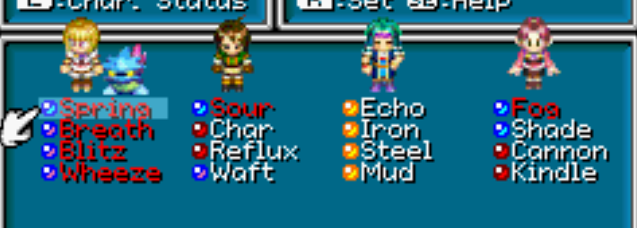
SB: Fog [j] -> Sour [f] -> Spring to Wheeze[s]

Items: Any sleep bombs to Jenna

T1: Sleep/Waft/Boreas/Shade
T2: Thor/Attack/WishWell/[Sleep Bomb]
T3: Spring/Sour/WishWell/Fog
T4: Def/Atk /Boreas/Shade

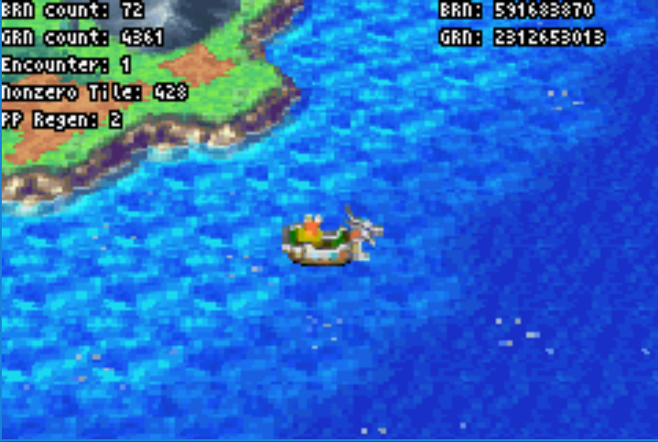
Note that a shopping trip in Champa to get Silver Armlets for Jenna and Sheba may increase chances against Poseidon (but may affect the money route for later in the game meaning more things need to be sold). In theory these should allow JS to survive atk/counter-rush with more than 50% HP. [Viking Helm to Piers for more Safety]

Take a trip to Apojii to get Haze [right from champa, then down+right from the picture] then head to the sea of time.
[up+left from Apoji until second picture, then left]
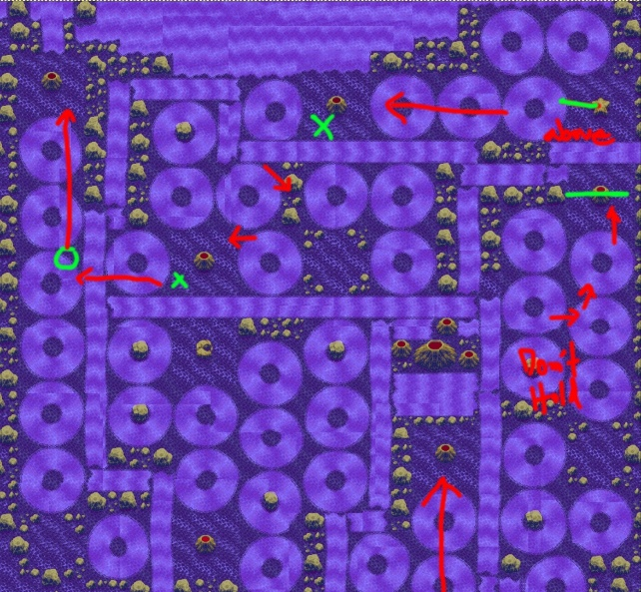
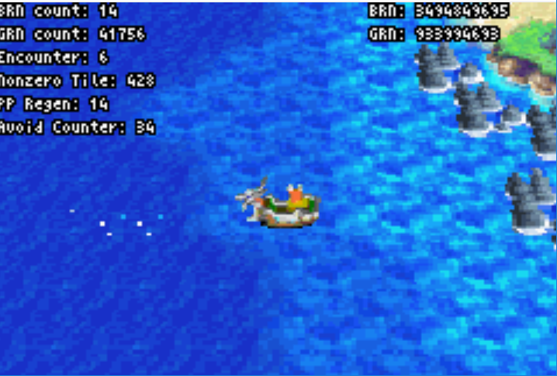

POSEIDON

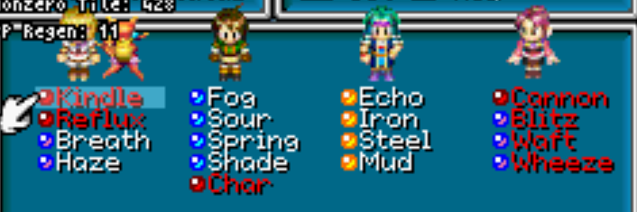
Wheeze [f] <-> Fog [j]
Shade [j] <-> Waft [f]
Spring [s] <-> Reflux [f]
Fog [s] -> Felix
Blitz [s] <-> Kindle [j]

Set all
SB: Blitz, Waft Wheeze, Cannon [all on J], Char [f], Kindle, Reflux [on S]

Trident to Sheba!

Sample Fight:
T1: Trident/Atk/WishWell/Meteor
T2: Mercury/Shade/WW/Cycle Beam
T3: Kindle/Char/WW/Cannon
T4: Reflux[f]/Shade/WW/Meteor
T5: Haze or Breath/Atk/WW/Cycle Beam
T7: Thor/Char/WW/Cannon
T8: Def/Atk/WW/Kirin

This fight really sucks, three revive sources: WOL on Sheba, Revive on FP. This fight will definitely go off script as Poseidon can kill people by looking at them the wrong way.
Note that Kirin will deal about 500 damage, Mars deals 300, both useful to finish the fight
Note that Felix retains Revive with 2 Mercury djinn set.

LEMURIA

Get Mist Potion from the Ship (where Aqua Hydra was killed) before leaving Lemuria
Get Eclipse, there is a backup lucky medal just down+right of the fountain (use reveal to see where to scoop) and another backup medal at the top right of the right side of Hydros’ palace.

POST LEMURIA

Items: Grind Stone to Felix, Mist Potion to Felix

Save the djinn menu until Grinding in Gondowan Cliffs, Felix has Avoid

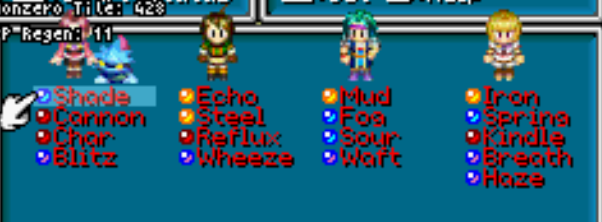
Fog [f] <-> Echo [p]
Waft [j] <-> Char [f] -> Piers
Iron [p] -> Sheba
Reflux[s] <-> Spring[f]
Shade [f] <-> Wheeze [j]
Steel [p] <-> Sour [f]

Sheba Slot 4, Jenna Slot 1

SB all [probably don’t need to set Shade until Atteka overworld, but the safety option is there]
Summon Eclipse with Sheba, and kill off anything else strategically. Use Shade if you don’t think things will die / you will take excessive damage. Eclipse will kill any targeted enemy, but won’t kill tough enemies (Dragon/Hydra) unless targeted. Hydras are slow so can be killed off by Felix attacking after an Eclipse.

[Fights take about 10s down from 20s]

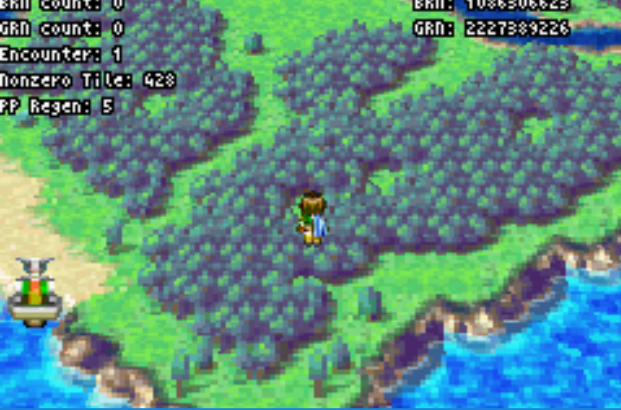
Get Chill on the way to Hesperia
(Chill is found in the forest depicted on the right)
Chill: Def/Meteor/Def/Tornado

Get Petra before Shaman Village
Petra: Meteor+Eclipse (worth using Shade here)

Enter in this river to get to Petra:
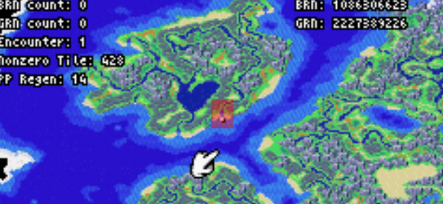
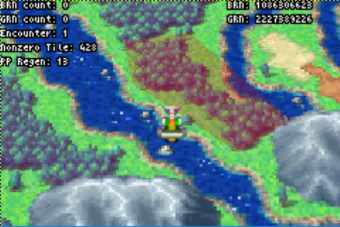
Petra in this forest:

After Petra continue along the river to get to Shaman Village
When SB’ing djinn prior to cave;
Chill [j] -> Piers, Waft [p] <-> Petra [f]

SHAMAN VILLAGE CAVE

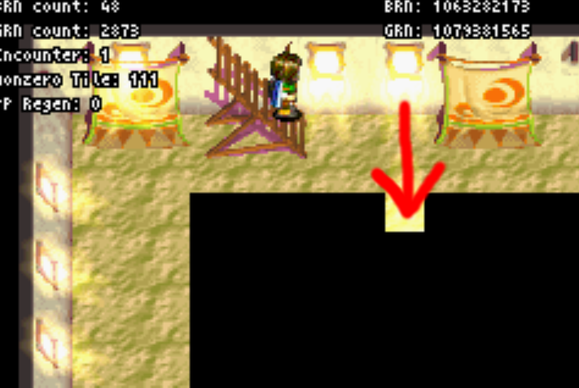
Be aware that djinn don’t recover here. Move cancel on the log to
drain Felix’s PP to 2pp before moving on to Shaman Village

SHAMAN VILLAGE

Bunch of retreat warps now to get Aroma. Go into the Inn and
go down the stairs. Retreat warp through the indicated door:

After warping, go up+right and move the pillar out of the way.
Backtrack and retreat warp through the next indicated door.
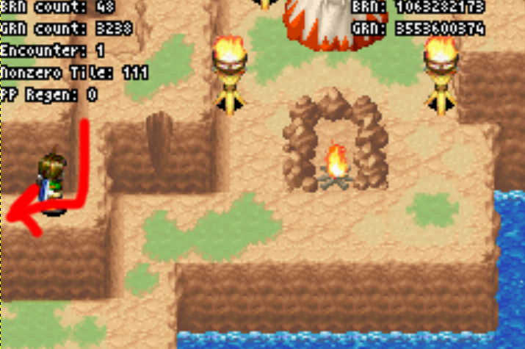
You’ll end up in a house, go up and up the stairs. Then retreat warp
Back down the stairs as indicated.

Now just head to Moapa, show him the Shaman’s Rod
Once you enter Trial Road (i.e. area with the Tornado Statue)
go into retreat mode (be careful that you haven’t recovered
extra pp).
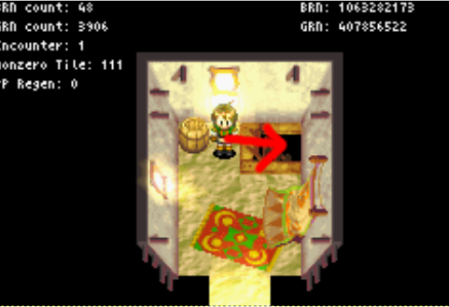
Progress through to the tutorial and once the Knights enter
trial road you will be warped to the Sanctum. Run back to Trial Road and Moapa’s tutorial will be skipped (saves 20s).
Pick the RIGHT path [note you get a full heal/revive here]

Weapons and Jennas Gloves into boxes except for Sol Blade
DROP THE SOL BLADE, WAR GLOVES and THORN CROWN PRIOR TO MOAPA

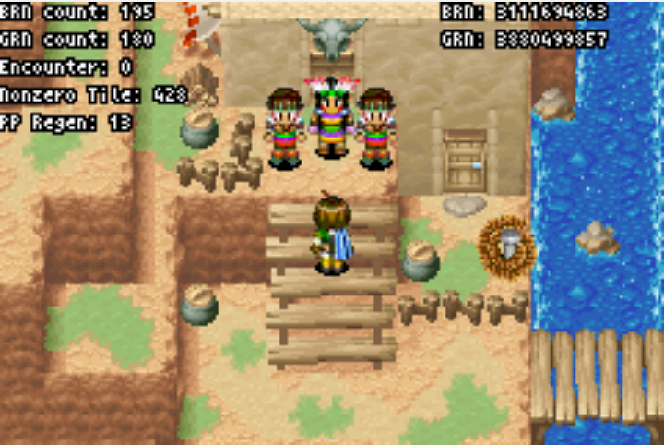
MOAPA

This fight is all about strategic djinn recovery, Summons target Moapa except as otherwise indicated

Djinn:

SB all. Set Shade, Mud, Petra, Iron
Double tap Blitz, Waft, Breath [all needed for Haze!!]
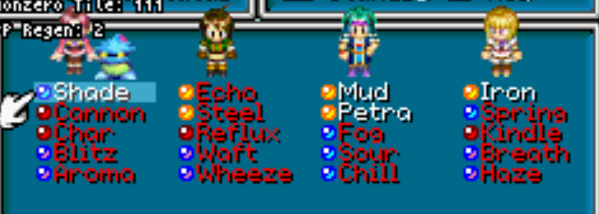
Items should be good to go (Mist Potion to Felix if you forgot)

T1: Shade/Mist Potion/Mud/Eclipse (Left Knight)
T2: Meteor (Left Knight)/Judgement/Petra (Moapa)/Eclipse
T3: Aroma/Wheeze/Fog/Haze (sheba)
T4: Def/Def/Def/Eclipse (Right Knight)

If Knight use nuts then don’t defend on T4.
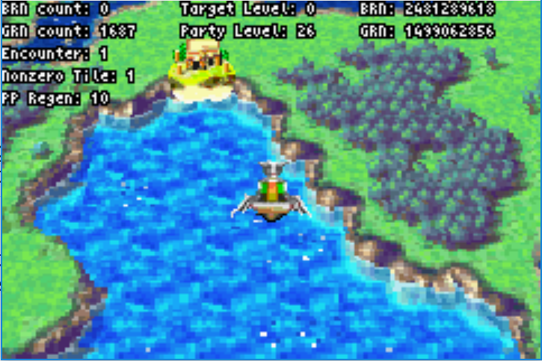
JUPITER LIGHTHOUSE

Park your boat so that you can hop into it from the mainland.
(Up+Right after entering the inlet until the mountain range on the top left is on its last pixel, then hold up.)

Things in the Contigo overworld are fast and hurt, using shade may be wise.

Get Salt on the way to Jupiter, put it on Felix

Eclipse will kill everything targeted except Blue Dragon, won’t kill Mace Tail not-targetted.

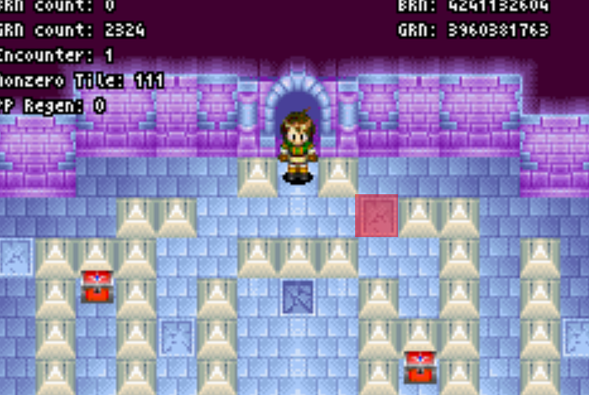
Go through Jupiter lighthouse as usual, at the top of the left wing drain Felix’s pp using move-cancelling on the pillar.

AFTER the getting the Blue Key go back up stairs, retreat mode, then fall down the indicated tile. [This activates falling coordinates allowing for a skip later on]

The fall should send you back to the start of Jupiter.

DO NOT LEAVE JUPITER LIGHTHOUSE WHILE FALLING COORDINATES ARE ACTIVE

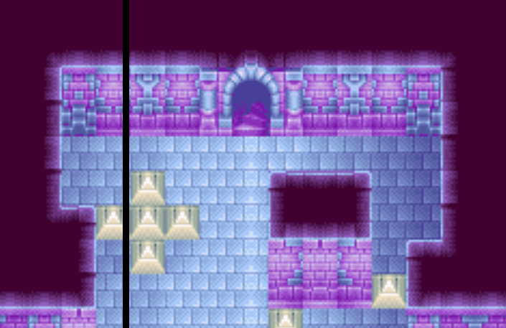
Now continue through the right side of Jupiter and
eventually you will out of bounds. Move Up+Right until the
Black Line on the image to the right is cut off from the screen.
After that hold up. This will skip two rooms.

The rest of Jupiter is easy. Don’t forget to die fast to A&K!
[Set Reflux on Felix, try to summon meteor to die]

CONTIGO

Reunion setup: [this can probably be optimised a bunch] [Get salt prior to this menu]

Echo [f] <-> Haze [s] <-> Zephyr [v] <-> Fizz [m] <-> Ground [g]
Forge [g] <-> Flint [I]
Tonic [I] <-> Gust [g] <-> Sap [V]
Salt [V] <-> Hail [I] <-> Torch [g]

Luff [m] <-> Breath [s]
Iron [s] <-> Aroma [j] <-> Chill [p] <-> Granite [I] <-> Fever [g] -> Mia
Breeze [m] <-> Petra [p]
Steel [f] <-> Blitz [j] <-> Spritz [V] <-> Spring [s] <-> Kite [m] [re-enter djinn menu]

Reflux [f] <-> Char [j] <-> Sour [p]
Fog [p] <-> Cannon [j]
Kindle [s] -> Garet
Flash [I] <-> Waft [f]

Isaac Slot 2
Ivan Slot 3
Piers Slot 5
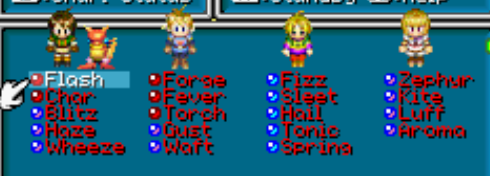
Sheba Slot 4

Items: Equip Lift gem to Garet, Frost Gem to Mia

Felix: Flash Char Blitz Haze Wheeze
Isaac: Forge Fever Torch Gust Waft
Ivan: Fizz Sleet Hail Tonic Spring
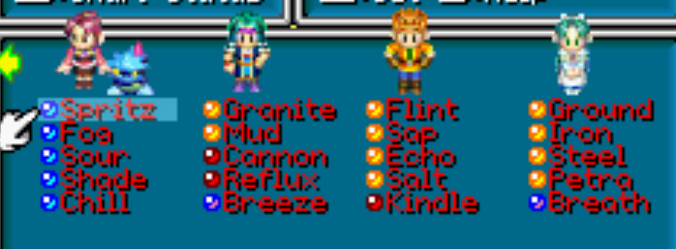
Sheba: Zephyr Kite Luff Aroma

Jenna: Fog Sour Spring Shade Chill
Piers: Granite Mud Cannon Reflux Breeze
Garet: Flint Sap Echo Salt Kindle
Mia: Ground Iron Steel Petra Breath

Hopefully you positioned the boat correctly and can hold Down+Right as you jump into the boat

MAGMA ROCK

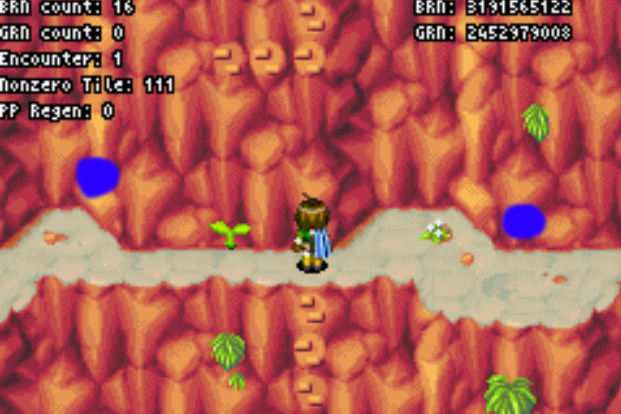
Things hit really hard and fast. Definitely make use of Flash against Gryphons, Boulder Beasts, Phoenix and anything you can’t kill in one turn with Eclipse.

Monsters which don’t die to untargeted Eclipse: Phoenix, Chimera, Demon (80+HP)

Burst glitch is good!!

In the second screen use burst in the blue spots indicated in the picture.

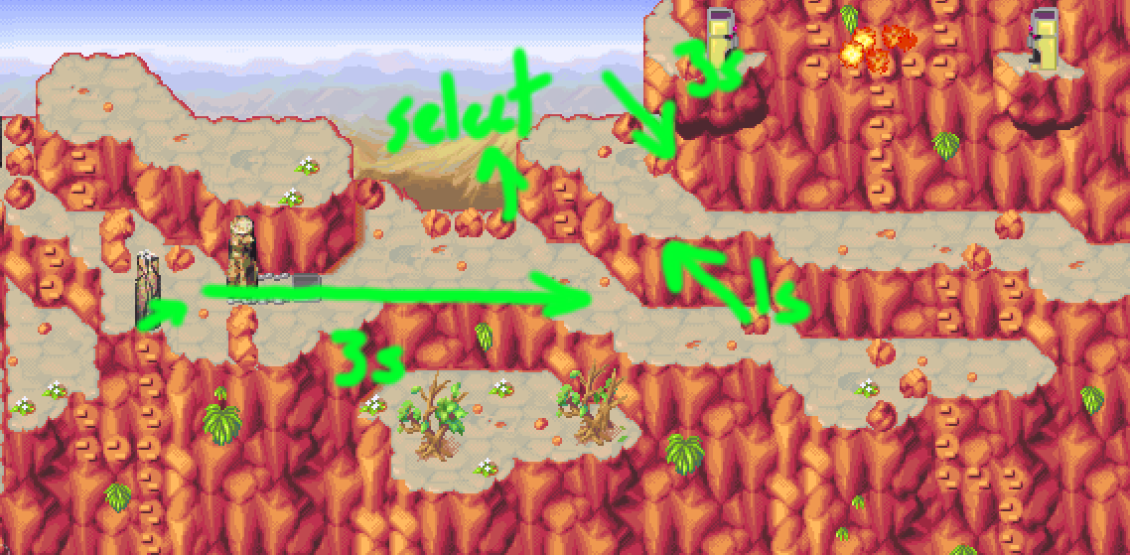
If attempting the blind climb, use the other picture to help guide you. (Drain pp on the log prior to the blimd climb screen)

Regardless, you’ll eventually end up inside. Activate the first large Moai and after crossing the lava lake you’ll come to the following room:
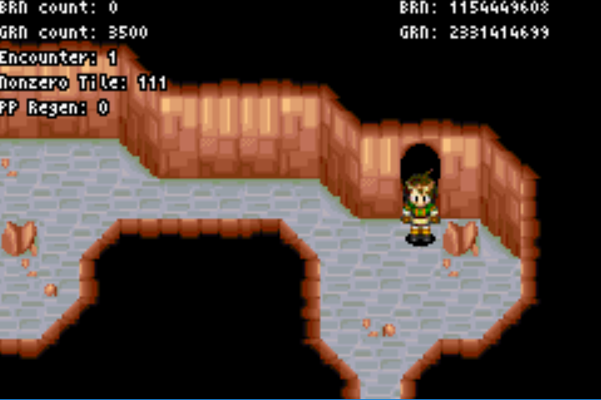

Retreat warp through the door. In this new room, retreat through the door again.
This will make Felix lava Jesus, the door is under the blue thing on the top wall.
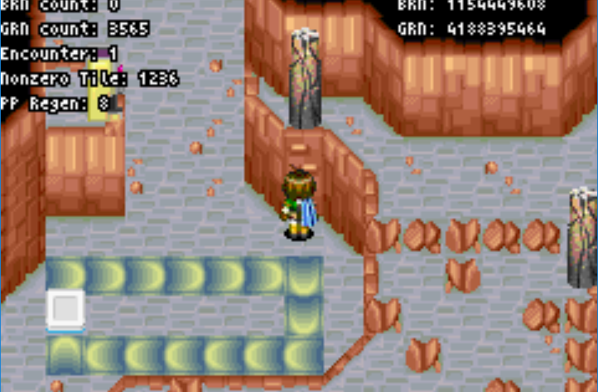
In the second level, simply walk down to the position on the right and use burst.

In the third level, follow the room normally until you drain the lava. Then burse glitch this Moai from the floor:
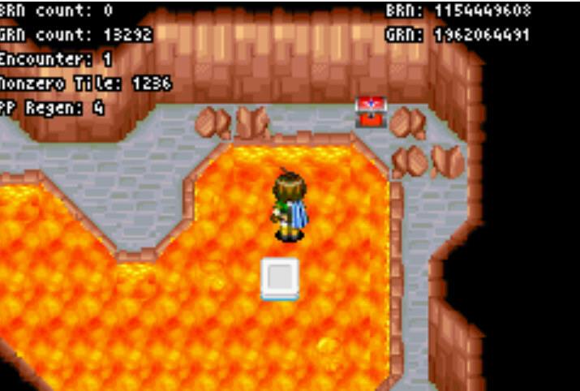
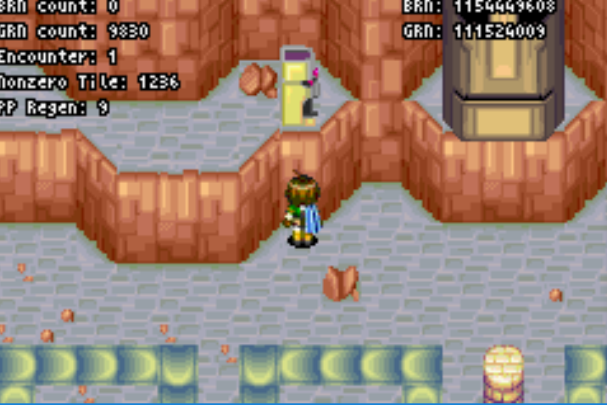

Go down after this and in the next room you’ll come to this bit. You can climb up from where Felix is positioned in the picture. Then progress through to the end of the level.

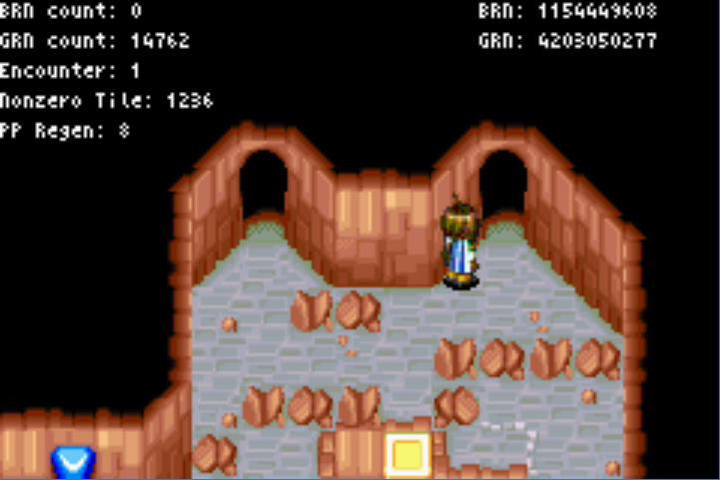
After the third level, exit Magma Rock via the alternate entrance then reenter. Backtrack to this position
and retreat glitch through the door to warp to the burst chamber. Don’t forget to get the Magma Ball on the way out.

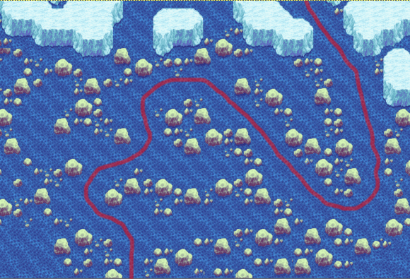
LOHO

Get Lull.

NORTHERN REACHES

Same enemies as Magma Rock.

PROX

Heal at the Inn. Get Mold.
Buy the Sol Blade, War Gloves/T Crown and a Mist Potion for Isaac. WOL on Ivan is useful.
Get the GS1 Merc djinn from Felix’s house.

Djinn: Mold [f] <-> GS1 Merc [I] <-> Breath [m]
Kindle [g] <-> GS1 Merc [f]
Wheeze [f] <-> Gust [I]
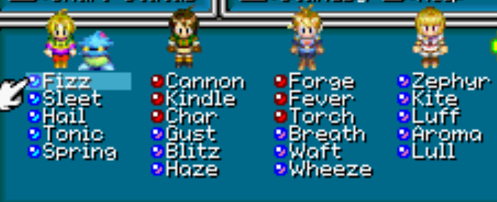
Flash [f] <-> Cannon [p]

Ivan to Slot 1

MARS LIGHTHOUSE

Mars:
V: Fizz Sleet Tonic Spring Hail
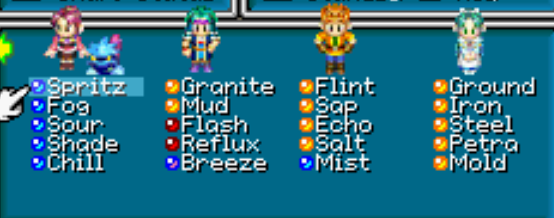
F: Cannon Char Kindle Gust Blitz Haze
I: Forge Fever Torch Breath Waft Wheeze
S: Zephyr Kite Luff Aroma Lull

J: Spritz Fog Sour Shade Chill
P: Granite Mud Flash Reflux Breeze
G: Flint Echo Ironc Steel GS1Merc
M: Sap Ground Salt Petra Mold

Kill Table:
 | Shuriken [I] | Shuriken [F] | Shine Plasma | Tornado
Doodle Bug | X | X
Frog | X | X
Raptor | X | X
Minos | X | X | [Ray]
Aka Manah | X | X | X | X
Firebird | X | X
With double War Gloves/TCrown Minos are a range on entering Mars, so Ray with Sheba
Use x2 Atk to kill off Single Target enemies (including Aka Manahs which need an extra Tornado)

Not much to say here otherwise. You can use the open djinn or status menu trick to bypass the flame spitting statues if you are confident. [potentially saves 54s with no fails]
Hotkey Burst prior to Flame Dragons (because we are going into Mars Win after this)

FLAME DRAGONS

Cannon[f] <-> Ground[m]
Petra[m] <-> Kindle[f]
Char[f] <-> Wheeze[I]

SB all, set Ground, Petra, Zephyr, Kite, Flash, Shade

Isaac <-> Piers
T1: Eclipse(L)/Ground(R)/Flash/Kite(V)
Jenna <-> Piers
T2: Eclipse(L)-Eclipse(R)/Petra(R)/Shade/Zephyr
Sheba <-> Garet
T3: Boreas(R)/Judgement(L)/Merc(R)/Def

Post Flame Dragon:
Ground[f] <-> Cannon[m]
Kindle[m] <-> Petra [f]
Wheeze[f] <-> Char[I]

Ivan slot 2
Sheba slot 1
Isaac slot 3

MARS LIGHTHOUSE PHASE 2

Do the Mars Wing first, then Jupiter, then Mercury. Use the flame in Mercury to drain PP for retreat glitch Venus activation.

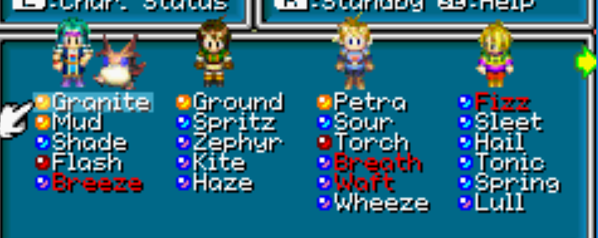
DOOM DRAGON

Cannon[f] -> give Sheba
Lull[s] -> Give Ivan
Spritz[j] <-> Kindle[f]
Char[f] <-> Zephyr[s] <-> Fog[j]
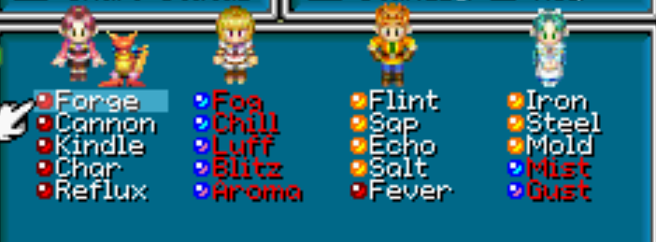
Sour[j] <-> Forge[I]
Fever[I] <-> Petra[m] <-> Gs1 Merc[g]
Ground[m] <-> Gust[f]
Blitz[f] <-> Kite[s]
Cannon[s] <-> Chill [j]
Shade[j] <-> Reflux[p]

Sheba to Slot 5, Piers to Slot 1
SB: Breeze[p], Breath[I], Waft[I], Fizz[V], all djinn on Sheba, J/Me djinn on Mia

Piers: Granite Mud Shade Flash Breeze[sb]
Felix: Ground Spritz Zephyr Kite Haze
Isaac: Petra Sour Torch Breath[sb] Waft[sb] Wheeze
Ivan: Fizz[sb] Sleet Tonic Spring Chill Lull

J: 5Ma
S: 2Me 3J [all sb]
M: 1J 1Me [sb] + stuff
G: 4V (Revive)

Items: Mist potions to Isaac/Felix.

Strategy run down:
Piers is using Flash or Granite or Shade. Someone needs to summon Mars/Venus each turn. Shade can be summoned via Eclipse.
Felix and Isaac are cycling djinn or summoning mars/venus. Ground/Petra to stop djinn blast/storm. Haze/Breath are priority djinn that can be used to get to 3J for Eclipse. Kite can be used to summon/heal with Ivan, granite/set flash with Piers. Djinn/mist potion on Isaac.
Ivan is mostly summoning mars/venus/eclipse, using tonic or healing when needed. Lull acts first so can be used to get an extra round of djinn refresh (useful when Piers needs to recover Flash for instance) and can skip a Guard Aura turn.

Jenna is backup healing (e.g. Ivan gets Djinn Blast T1)
Sheba comes preloaded with an eclipse, swap her in to deal the killing third eclipse in Phase 1 or 3

Phase 1 is Thor + 3 Eclipses [5000 hp] or Thor+2 Eclipse +Procne
Phase 2 is 3 Eclipses [4200 hp] (or 2Eclipse + Procne + 700 incidental, tend to be 150 dmg short)
Phase 3 is 3 Eclipses [4000 hp] (or 2Eclipse + Procne/Boreas + 600 incidental)
Often you’re hitting the incidental, so can gamble on the Procne kill

 | Act 1 | Act 2 | Act 3 | Act 4 | Act 5 | Act 6 | Act 7 | Act 8
Phase 1 | DjinnB | Haunt | Curse | Thorn | Haunt | Curse | Def | Thorn
Phase 2 | EarthF | GuardA | Haunt | DjinnB | GuardA | EarthF | Spire | Curse
Phase 3 | Darksol | GuardA | DjinnS | EarthF | GuardA | Darksol | EarthF | Nettle

Turn 1: Flash/Haze/Mars/Thor

If HAUNT:
ACTION 5 [Curse-Def]

Def/Def/Def/Lull
Shade/Haze/Breath/Eclipse
Flash/Kite[p]/Wheeze/Tonic
Set Flash-Shade/Haze/Waft/Eclipse
[Mia]/Def/Breath/Procne

Flash/Spritz/Petra/ShineP
Flash/Haze/Petra/Lull
Shade/Zephyr/Breath/Eclipse
Flash/Kite[p]/Petra/Tonic
Shade-Flash/Ground/Sour/WishWell
Def/Ground/Breath/Lull
Flash/Spritz/Wheeze/Eclipse
Flash/Haze/Waft/Procne
[expect DD to get off Spire before Waft]

Flash/Zephyr/Breath/WW
Flash/Def/Petra/Lull
Flash/Kite[p]/Wheeze/Eclipse
Shade-Flash/Haze/Petra/Tonic
Flash/Ground/Def/Eclipse
[Sheba]/Def/Def/Eclipse
ACTION 2 [Curse-Thorn]

Def/Def/Def/Lull
Shade/Haze/Breath/Eclipse
Flash/Kite[p]/Wheeze/Tonic
Set Flash-Shade/Haze/Waft/Eclipse
[Mia]/Def/Breath/Procne

Flash/Zephyr/Petra/WW
Flash/Haze/Petra/Lull
Flash/Kite[p]/Sour/Procne
Flash-Shade/Spritz/Wheeze/ShineP
Flash/Zephyr/Breath/Eclipse
Flash/Haze/Def/Lull
Shade/Atk/Atk/Eclipse

Flash/Kite/Petra/WW
Flash-Shade/Spritz/Waft/Tonic
Def/Def/Breath/Lull
Flash/Zephyr/Sour/Eclipse
Granite/Haze[V]/Wheeze/Eclipse
[Sheba]/Def/Def/Eclipse

If CURSE
ACTION 3 [Thorn]

Def/Def/Def/Lull
Shade/Haze/Breath/Eclipse
Flash/Kite[p]/Wheeze/Tonic
Flash-Shade/Haze/Waft/Eclipse
Flash/Zephyr/Breath/WW
Flash/Def/Def/Procne

Flash/Kite[p]/Wheeze/Tonic
Flash-Shade/Haze/Sour/Eclipse
Def/Def/Breath/Lull
Flash/Kite[p]/Wheeze/WishWell
Flash-Shade/Zephyr/Petra/Eclipse
[Mia]/Ground/Ramses/Procne

Flash/Kite[p]/Waft/Tonic
Flash-Shade/Haze/Mist Potion/Eclipse
Flash/Zephyr/Breath/WW
Flash/Def/Def/Lull
Flash/Def/Wheeze/Procne
[Sheba]/Ground/Waft/Eclipse
ACTION 6 [Defend]

Def/Def/Def/Lull
Shade/Haze/Breath/Eclipse
Flash/Kite[p]/Wheeze/Tonic
Flash-Shade/Haze/Petra/Eclipse
Flash/Zephyr/Sour/WW
[Mia]/Atk/Breath/Eclipse

Flash/Haze/Petra/Lull
Flash/Kite[p]/Sour/ShineP
Flash-Shade/Spritz/Petra/Eclipse
Flash/Zephyr/Waft/Tonic
Flash/Def/Def/Lull
Flash/Haze/Wheeze/Eclipse
Flash/Astral Blast/Breath/Procne

Flash/Kite[p]/Waft/Fizz
Flash-Shade/Zephyr/Sour/Wishwell
Flash/Haze/Breath/Eclipse
Flash/Def/Def/Lull
Shade/Ground/Def/Eclipse
[Sheba]/Def/Def/Eclipse

If THORN
ACTION 4 [ X – Curse]

Granite/Zephyr/Petra/Ramses
Def/Def/Def/Lull
Shade/Spritz/Breath/Eclipse
Flash/Kite[p]/Wheeze/WW
Flash-Shade/Zephyr/Breath/Eclipse
[Mia]/Haze/Atk/Procne

Flash/Spritz/Wheeze/Tonic
Flash/Def/Breath/Lull
Flash/Kite[p]/Waft/Eclipse
Flash-Shade/Haze/Petra/Procne
Flash/Zephyr/Sour/WishWell
Flash/Def/Breath/Lull
Def/Astral/Waft/Eclipse

Flash/Kite[p]/Wheeze/Tonic
Flash-Shade/Haze/Sour/Eclipse
Flash/Zephyr/[Sheba]/Eclipse
Shade/Def/[Isaac]Breath/Eclipse
ACTION 8 [X – Haunt]

Granite/Zephyr/Petra/Ramses
Def/Def/Def/Lull
Shade/Spritz/Breath/Eclipse
Flash/Kite[p]/Wheeze/WW
Flash-Shade/Zephyr/Breath/Eclipse
[Mia]/Haze/Atk/Procne

Flash/Spritz/Wheeze/Tonic
Flash/Def/Breath/Lull
Flash/Kite[p]/Waft/Eclipse
Flash-Shade/Haze/Def/Procne
Flash/Zephyr/Sour/WishWell
Flash/Def/Breath/Lull
Def/Astral/Waft/Eclipse

Flash/Kite[p]/Wheeze/Tonic
Flash-Shade/Zephyr/Petra/Eclipse
Flash/Ground/[Sheba]/Eclipse
Def/Def/[Mia]/Lull
Shade/Haze/[Mia]Def/Eclipse

If DEFEND
Def/Def/Def/Lull
Shade/Haze/Breath/Eclipse
Flash/Kite/Petra/Spring
Flash-Shade/Haze/Breath/Eclipse
Flash/Zephyr/Sour/Def
[Mia]/Def/Breath/Eclipse

Flash/Haze/Petra/Lull
Flash/Ground/Wheeze/Tonic
Shade/Zephyr/Petra/Eclipse
Granite/Spritz/Cybele/WW
Shade/Haze[p]/Breath/Eclipse
Flash/Def/Def/Lull
Flash/Zephyr/Wheeze/WW
Flash/Def/Def/Procne

Flash/Kite[p]/Waft/Tonic
Flash-Shade/Haze/Petra/Eclipse
Flash/Ground/[Sheba]def/Eclipse
Def/Def/[Isaac]Sour/Lull
Shade/Haze/Breath/Eclipse
If DJINN BLAST
PIERS

Def/Def/Def/Lull
Shade/Haze/Breath/Eclipse
Flash/Kite[p]/Wheeze/Tonic
Set Flash-Shade/Haze/Waft/Eclipse
[Mia]/Def/Breath/Procne

Flash/Zephyr/Wheeze/Tonic
Flash/Haze/Def/Lull
Shade/Spritz/Waft/Eclipse
Flash/Kite[p]/Breath/ShineP
Flash-Shade/Haze/Wheeze/Eclipse
Def/Atk/Atk/Procne

Flash/Spritz/Waft/Tonic
Flash/Haze/Breath/Lull
Flash/Zephyr/Petra/Eclipse
Shade/Kite[p]/[Sheba]def/Eclipse
Def/Ground/[Mia]/Eclipse
FELIX

Def/Def/Def/Lull
Shade/Haze/Breath/Eclipse
Flash/Kite[p]/Wheeze/Tonic
Flash-Shade/Def/Breath/Eclipse
Def/Def/Def/Lull
Flash/Zephyr/Wheeze/WW
Def/Def/Def/Procne

Shade/Kite[v]/Waft/Tonic
Flash/Haze/Wheeze/WW-Lull
Flash/Zephyr/Sour/Eclipse
Granite/Spritz/Breath/Procne
Shade/Kite[P]/Waft/WW
Flash-Granite/Ground/Atk/Eclipse

Flash/Zephyr/Petra/WW
Flash/Ground/Petra/Lull
Flash/Kite[p]/Wheeze/Tonic
Flash-Granite/Spritz/Petra/Eclipse
Flash/Haze/[Sheba]def/Eclipse
Shade/Def/Breath/Eclipse

ISAAC

Def/Def/Def/Lull
Shade/Haze/Breath/Eclipse
Flash/Kite/Waft/Tonic
Flash-Shade/Haze/Wheeze/Eclipse
Def/Def/Def/Lull
[Mia]/Atk/Atk/Procne

Flash/Kite[p]/Sour/Tonic
Flash-Shade/Haze/Breath/Eclipse
Flash/Zephyr/Mist Potion/SPlasma
Flash/Def/Def/Lull
Flash/Kite[p]/Sour/SPlasma
Flash-Granite/Haze/Wheeze/Eclipse
Granite/Ground/Breath/Procne

Flash/Zephyr/Petra/Tonic
Flash/Ground/Petra/Lull
Shade/Haze/Waft/Eclipse
Flash/Kite[p]/Sour/WW
Flash-Shade/Ground/Eclipse
[sheba]/Def/Def/Eclipse
IVAN

Granite/Kite/Wheeze/Def
Flash-Shade/Spritz/Breath/Pronce
Granite/Haze/Def/Lull
Flash/Kite[p]/Sour/Lull
Flash-Granite/Zephyr/Breath/Eclipse
Flash/Mist Potion/Wheeze/Tonic
Flash/Def/Breath/Eclipse

Granite/Haze/Def/Lull
Flash/Kite[p]/Sour/ShineP
Flash-Shade/Zephyr/Petra/Eclipse
Flash/Spritz/Breath/Tonic
Flash/Def/Def/Lull
Flash/Kite[p]/Wheeze/Eclipse
Breeze-Flash/Haze/Waft/Procne [kills by 16]

Flash/[Sheba]SPlasma/Breath/Eclipse
Flash/Def/Petra/Lull
Flash/Zephyr/Sour/Procne
Shade/Haze/Wheeze/Eclipse
Def/Atk/Atk/Jupiter
Y-Y-N-Y in the leaving Prox Cutscene.

